http://www.grapevine.is/Home/ReadArticle/The-Critic

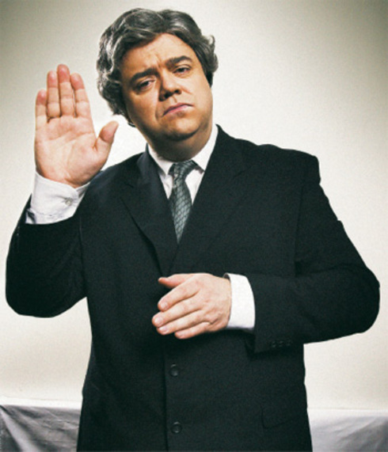

**The Critic**

An interview with Örn Árnason

5.12.2005

Words by [Sveinn Birkir Björnsson](http://www.grapevine.is/Author/Sveinn-Birkir-Bj%C3%B6rnsson)

The most popular comedy program in the country, the comedy troupe behind the show Spaugstofan recently celebrated 20 years working together. Founding member, and former Grapevine cover boy, Örn Árnason sat down and explained the appeal of his program.  
/// After 20 years in the business, is Spaugstofan still funny? Do you ever feel like it’s hard to stay fresh?  
– It depends on what you mean by staying fresh. We are just doing a certain type of social commentary. We try to look behind the curtains and see if we can put a twist on daily life, without trying to hurt anyone’s feelings. Of course, it can be difficult to come up with ideas, but we try.  
Our biggest advantage is that we are very critical of ourselves and we think we know when our time has come. That’s why I think we are still able to do this sort of commentary some justice.  
/// How do you explain the popularity of the show?  
– People like to laugh and they want to have fun. I think Icelanders like social commentary and they like to laugh at their fellow man. I think that is the main reason.  
/// As you said earlier, a lot of your material could be categorised as social commentary. You have dealt with some inflammatory issues such as the oil scandal, the Baugur trial and so forth. Can you explain how the show developed in this direction?  
– Isn’t it the nature of this kind of show? Not just here in Iceland, but everywhere. We were doing this sort of commentary from the beginning, since the concept of the show really evolved from us doing Skaupið [A comical version of the year in review, shown on Icelandic TV on every New Year’s Eve] together, which is just pure social commentary. That’s where we began. That is when the idea came to do a weekly TV show. Sometimes there are a lot of issues to deal with, but sometimes there is nothing. That is when we have to do what we call all-season comedy, trying to make everyday life comical.  
/// Do you feel you have obligations as social commentators?  
– Yes, I think we do. I think it is necessary that there be a show like this one that says: “You are being watched, people are laughing at you.” Like someone once said to me: “You guys dare to say what normal people are thinking.”  
Sometimes these issues have been covered extensively in the news, but then we try to look beyond that and really try to see what the issue is like. For example, an idea we discussed this morning, with the hospital beds in Sólvangur [a retirement home], there are 15 cm between them, isn’t it then necessary to hire people to work there that fit between these 15 cm? Then people would just be measured and… “Sorry, you are just too fat to work here.” Just to try and twist it like that.  
How do health authorities react? Well they hire a staff that fits instead of trying reduce the number of beds.  
/// Have your “victims” spoken out against you? Have people been mad or thought you treated them unfairly?  
– Well, just in the last few days I’ve heard that the Prime Minister (Progressive Party MP Halldór Ásgrímsson) has been complaining in the newspapers and the radio. He is not happy with the way Pálmi [the actor who routinely portraits the Prime Minister] has portrayed him. His complaint is that Pálmi doesn’t know him at all, and that it should be the minimum requirement for an actor to know his subject. I think these are rather sheepish remarks actually.  
/// Is he setting himself up for further parody?  
– Well, I don’t know… (laughing) I am not sure how we should deal with this.  
/// When something is highly publicised in the news, I’ve often heard people say: “I can’t wait to see how Spaugstofan will spin this.” Do you think that politicians or businessmen wonder how they are going to be portrayed on the show?  
– No. I don’t think so. I think it is only the consumer that thinks about this. But we have never tried to follow what the consumer wants. We just try to do things according to our own conviction. Sometimes people will come up to me in the hot tubs and say: “I missed that you didn’t do anything on this or that issue.” But then we may have thought it didn’t warrant anything, or there was no side for us to approach it from.  
There are issues that are ideal, but we would rather not take the issues just like they are, we prefer to put a little twist on them. If we can’t, then we skip them. We have never felt compelled to cover a certain issue. Sometimes there are issues that we feel we need to show certain solidarity with, by pointing out how absurd they are, like the situation with the retirement home. We enjoy the privilege of being our own editors, so we can do that, but our goal is usually to just have fun.  
We are a comic show, so we can’t get caught up in the bleakness of things. There have been issues that we have covered and we can do them so… (pauses) we can slaughter people. This is such a strong medium. It’s not in our favour to be untactful, but to make it fun for the viewer, give him a few laughs. That is our goal. We have a certain moral threshold that we do not exceed.  
/// Does Icelandic society produce an endless stream of material for a show like Spaugstofan?  
– Yes. Definitely.  
/// After having developed a successful formula for a show, how come nobody is following you guys? It seems to me that no other show out there is focusing on social issues. Why is nobody trying to emulate your success with political satire / social commentary?  
– I don’t know what to tell you (pauses) we have the advantage that we are all pretty bright. We all have opinions on the society. We have a very good writer [Karl Ágúst Úlfsson]. That is our strength.  
/// Has Spaugstofan become a social institution?  
– No, never. If we were, then we would be printing t-shirts and coffee mugs. We have never tried to act on our popularity in that way. Maybe that is why we still manage to stay popular. We try not to drown people with our constant presence.  
/// So you’re not in it for the money?  
– No. Of course it’s not bad when that comes along with it, but as soon as that day comes, not just with this but everything, then you should just move on to something else. I still like doing comedy and making children’s shows, but as soon as I don’t, I’ll be glad to do something else. When you are entertaining, you know when it is going well, you also know when it’s going bad and then it’s usually your fault, because you don’t feel like doing it. If that feeling stays with you, then it is time to call it quits.  
/// You have done a lot of singing, both on the show and as a solo act. Is that something that tickles you?  
– Yes. It always has and still does. I’ve just made the decision that I am going to put a band together and we are going to play at the next Iceland Airwaves festival.  
/// Really?  
– Yes. I have made the decision; we’ll see if I’ll follow through on that. I’d really like to do that.  
/// Well, in that case, you have now made the announcement here in the Reykjavík Grapevine so you will be forced to stick with it.  
– That is good. I hope I do.

Örn Árnason

Örn Árnason (born 19 June 1959) is an Icelandic actor, comedian and screenwriter, best known as a member of the comedy group Spaugstofan. He has starred in a number of films and television series since the 1980s, as well as acting in the National Theatre of Iceland. He is noted for his satirical portrayals of public figures, including former Icelandic Prime Minister Davíð Oddsson. Örn hosted the children's morning program Með Afa on Stöð 2. He is the son of actor Árni Tryggvason.